PSet3

CS 4649/7649 Robot Intelligence: Planning

Instructor: Matthew Gombolay

# Instructions:

* You may work with one or more classmates on this assignment. However, all work must be your own, original work (i.e., no copy+pasting code). You must list all people you worked with and sources you used on the document you submit for your homework
* Solutions to “by hand” problem must be enclosed by a box and be legible.
* You should submit your solutions to PSet 3 to Gradescope. The answers to problems 1-3 should be submitted as a PDF to the written portion of the assignment. The code should be submitted as a .py file to the code portion of the assignment. When you submit your code portion, Gradescope will inform you if you have submitted the correct file and your answers are in the correct format.

# Problem 1

Prove that the complexity of AC-3 is $O\left(ek^{3}\right)$. You are welcome to look up sources online to help with the proof, but the proof must be detailed and derived using your own words – no copy+pasting!

# Problem 2

For this problem, you will draw block diagrams describing the flow of Backtrack Search with Forward Checking and Dynamic Variable Ordering. An example block diagram for HOTPO is shown below. Please follow the same conventions for your solutions.

**Part A)** Draw a block-diagram describing Backtrack Search with Forward Checking and Dynamic Variable Ordering, based upon slide 63 (“Procedure Dynamic-Var_Forward-Checking(x,D,C)”).

**Part B)** Draw a block-diagram describing Backtrack Search with Forward Checking and Dynamic Variable Ordering, based upon slide 57 (“Procedure Select-Value-FC()”), which is a subroutine for the program you described in Part A.

# Problem 3

Implement the following algorithms to solve the n-queens problem, which is defined as the problem of placing n queens on a chess board of size n by n such that no queen can “take” another queen (i.e., no two queens should be on the same row, column or diagonal).

* Standard Search function: standard()
* Backtrack Search function: BT()
* Backtrack Search with Forward Checking (FC) function: BT_w_FC()
* Iterative Repair (Min-Conflict Heuristic) function: iterative_repair()

Generate a plot like the one below by trying n = {1,2,…} for each algorithm until the search method can no longer find a solution within 10 minutes of computation time. Include the plot in your PDF submission.

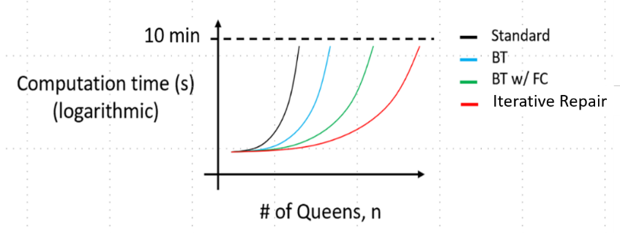

DO

Notes:

* Use the statespace convention we described with columns for variables and rows for the domain values.
* For Standard Search, Backtrack Search, and Backtrack Search with FC, use a fixed ordering assigning queens (your variables) based upon their column index, e.g., the queen in column one would be assigned first, the queen in column two would be assigned second, and so forth.
* For iterative repair, use a random initialization as your greedy heuristic. If after performing hill climbing, you cannot find a solution, generate another random solution (i.e., there should be a loop that keeps trying to find a solution for up to 10 minutes of computation).
* You should have one Python function for each type of search, and the code should be clearly documented. You must use the file template provided (pset3.py). Further, when the grader runs the python code, the function should return the time taken for each # of queens up to 10 minutes in a list. For example, if your first five times are 1 min, 2 min, 3 min, 5 min, and 10 min for n = 1, 2, 3, 4, and 5 respectively, you would return [1,2,3,5,10].
* The 10 minute time-out is not a cumulative time but a time per value of n. So, for example, if your first four times are 1 min, 2 min, 3 min, and 5 min for n = 1, 2, 3, and 4, respectively, you should keep going. You should keep going until, for some n large enough, that you cannot find a solution in <= 10 minutes for that single n-Queens problem.